44.40: 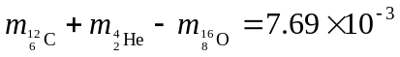u, or 7.16 MeV, an exoergic reaction.

